**SELECTION PARAMETER**

**FM’s to be included**

**BAPI_BUPA_ADDRESS_GETDETAIL  
BAPI_BUPA_ADDRESS_CHANGE  
BAPI_TRANSACTION_COMMIT**

**Screen 1**  
**Fields**

Business partner   
(After this it will automatically take you to but000 screen with grouping ZCCP)

Phone No.

Result

Function Specification

Step 1: Run T Code Se16n

Step 2: Open table BUT000

Step 3: Put ZCCP (Contact Partner) in

|  |  |
| --- | --- |
| **Field Name** | **Technical Name** |
| Grouping | BU_GROUP |

Step 4: Remove the maximum number of hits and after this execute. You can see all the Billing contacts business partner number.

Step 5: Then run T Code BP and put Business Partner number. There you can see telephone no.

Here the telephone no. should be blank for all billing contacts.

First, we have to check which billing contact have telephone number maintained. To check this

**Deletion scenario for telephone number from billing contacts**

Functional Specification

Step 1: Go to T code /Se37

Step 2: Put this BAPI **BAPI_BUPA_ADDRESS_GETDETAIL** in Function Module and execute

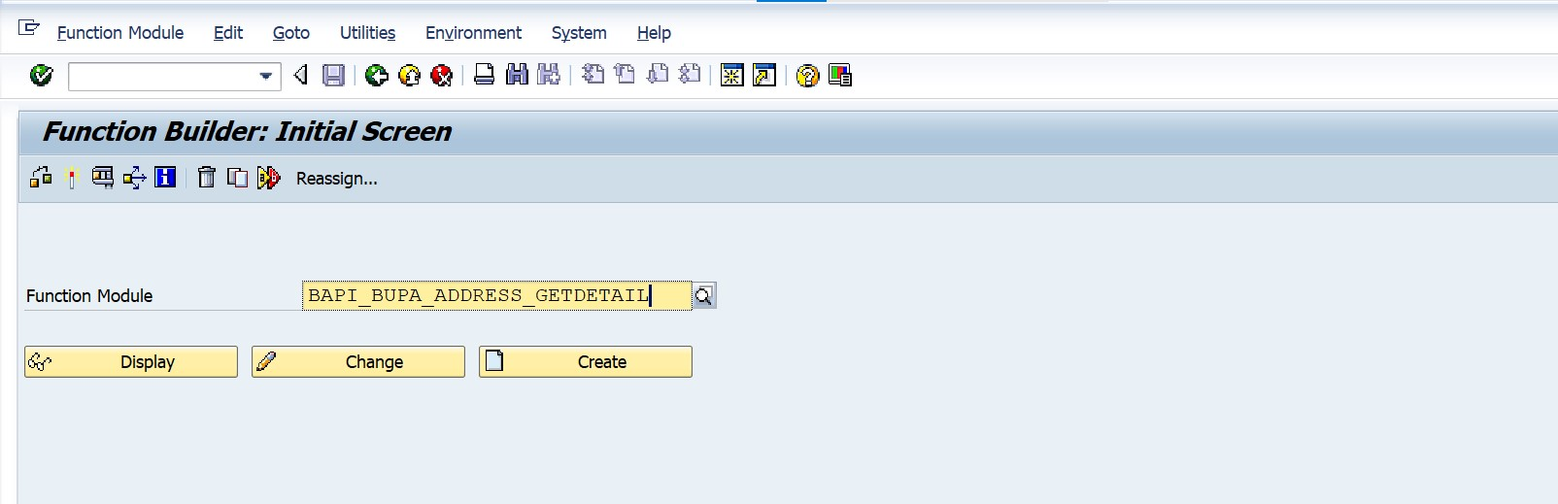

Step 3: Put Business Partner number in BUSINESSPARTNER field and execute

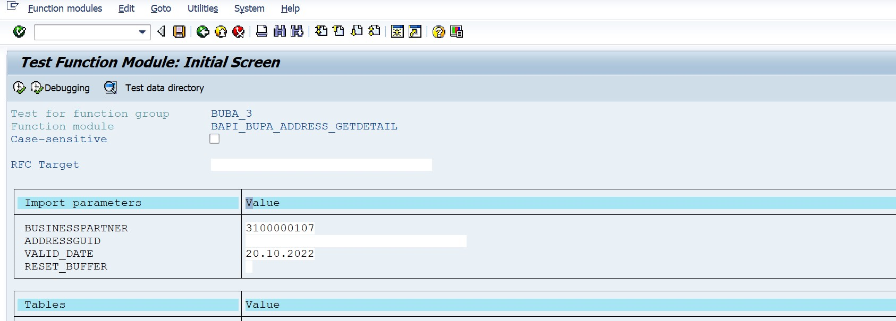

Step 4: Now take all the BP which is showing entry in result of BAPIADTEL

All the Business Partner will pass from

Step 2: Go to the tab of Functional module🡪 Execute🡪 Test sequence

Step 3: Select these two function modules in this particular order:

1. BAPI_BUPA_ADDRESS_CHANGE
2. BAPI_TRANSACTION_COMMIT

Step 4:

In Import parameters at **BUSINESSPARTNER** put Business Partner number

**In Tables**



In **BAPIADTEL** we have to put the telephone no. of the Business Partner



In **BAPIADTEL_X** we have to put these entry



TELEPHONE --- X

R_3_USER --- 1

UPDATEFLAG ---- D

After this go back and execute it

Step 5: We can see the Telephone no. is deleted from the Business Partner

